

Islamic Studies

First Assignment



SUBMITTED TO: dr. Mohsin

BS-SE 1st Semester

**Hamza Mehmood**

Numl-S21-23529



**Presented by: Group No 1**

|  |  |
| --- | --- |
| IICT REPORT | |
|  |  |
|  |  |



**Title LAB REPORT OF IICT**

|  |  |
| --- | --- |
| Submitted to | Mr. Talal Bin Afzal |
| Submitted by | Muhammad Irfan |
| Roll no | 2433 |
| subject | IICT Lab |
| department | CS (evening) |
| Semester | 1st |

Lab #01

Introduction to lab:

*A word processor is a computer program used to create and print text documents that might otherwise be prepared on a typewriter. The key advantage of a word processor is its ability to make changes easily, such as correcting spelling, adding, deleting, formatting and relocating text. Once created, the document can be printed quickly and accurately saved for later modifications.*

**Given below are the basic functions of Microsoft Word:**

* Creating text documents.
* Editing and Formatting the existing documents.
* Making a text document interactive with different features and tools.
* Graphical documents, comprising images.
* Used by Authors and Researchers.
* Detect grammatical errors in a text document.

LAB 2: HOME TAB



In first lab we have learnt the clipboard.

1. Move the cursor to the spot where you want to paste an item from the Word Clipboard.
2. Click the Word Clipboard icon. The Word Clipboard pane appears.

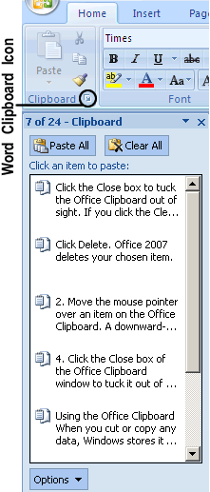

1. Move the mouse pointer over an item on the Word Clipboard. A downward-pointing arrow appears to the right. A pop-up menu appears and click Delete. Word 2016 deletes your chosen item.
2. Click the Close box to tuck the Word Clipboard out of sight.

If you click the Clear All button, you can delete every item currently stored on the Office Clipboard. Make sure you really want to delete an item from the Office Clipboard because after you delete it, you cannot retrieve it.

**Uses of clipboard:**

When you cut or copy any data, Windows stores it in a special part of memory called the Clipboard.

The two big advantages of the Office Clipboard are:

* You can store up to 24 items. The Windows Clipboard can store only one item.
* You can select what you want to paste from the Clipboard. The Windows Clipboard lets you paste only the last item cut or copied.

**FONT:**

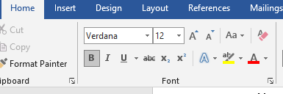

In the Fonts group, click the dialog box launcher button.

The button is found in the lower-right corner of the Font group

The Font dialog box’s Advanced tab hosts options for changing the size and position of text on a line.

The Set as Default button in the Font dialog box is used to change the font that Word uses for a new document. If you prefer to use a specific font for all your documents, choose the font (plus other text attributes) in the Font dialog box, and then click the Set as Default button. In the dialog box that appears, choose the option All Documents Based on the Normal Template, and then click the OK button. Afterward, all documents start with the font options you selected

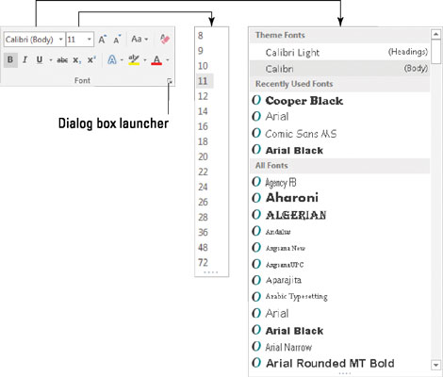

You can change font size and font style by using the font menu as shown above .

For example I want to change the size and style of dummy text below by using font menu:

Video provides a powerful way to help you prove your point. When you click Online Video, you can paste in the embed code for the video you want to add. You can also type a keyword to search online for the video that best fits your document.

To make your document look professionally produced, Word provides header, footer, cover page, and text box designs that complement each other. For example, you can add a matching cover page, header, and sidebar. Click Insert and then choose the elements you want from the different galleries.

I have applied the Algerian text on above document and size is 11 .

By using font menu we can also change the color of selected text.

For change the color of text:

1. Selected the text which you want to change the color.
2. Then go to font menu.
3. Then click on the font menu and where [A] is written from there we can change the color of text.
4. For example we want to change the color of this dummy text below.

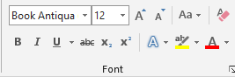

Video provides a powerful way to help you prove your point. When you click Online Video, you can paste in the embed code for the video you want to add. You can also type a keyword to search online for the video that best fits your document.

To make your document look professionally produced, Word provides header, footer, cover page, and text box designs that complement each other. For example, you can add a matching cover page, header, and sidebar. Click Insert and then choose the elements you want from the different galleries.



Bold Italic Underline

**Bold:**

**with the use of bold text we can bold our selected text.**

**Italic:**

*with the use of italic option we can change our selected text into italic text.*

**Underline:**

with the use of underline option we can make a underline our selected text.



Subscript superscript

1. **Subscript** is the text which a small letter/number is written after a particular letter/number. It hangs below its letter or number. It is used when writing chemical compound. An example of subscript is N2.
2. **Superscript** is the small letter / number above a particular letter / number. An example of superscript is 25. The number 5 above the number 2 is an example of superscript. Superscript can be used for exponents in mathematics.

LAB 3: Home Tab

Paragraph dialog box:

Follow the steps below to employ paragraph dialog menu:

First select the text or paragraphs on which you want to make changes like sorting, indenting, aligning or shading. Now we will discuss each one by one.

**1.Sorting:**

First Select the the paragraphs or passages. Then click on home tab as shown in fig.

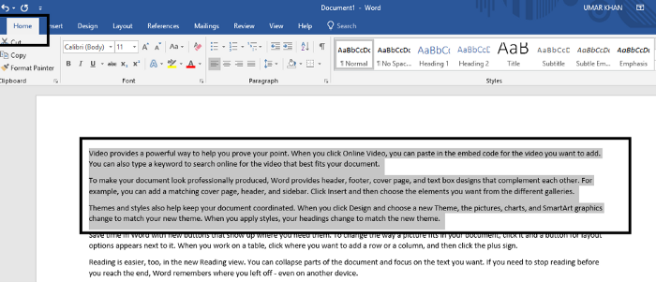

Go to paragraph dialog box and click on any first three options u wish to be selected.

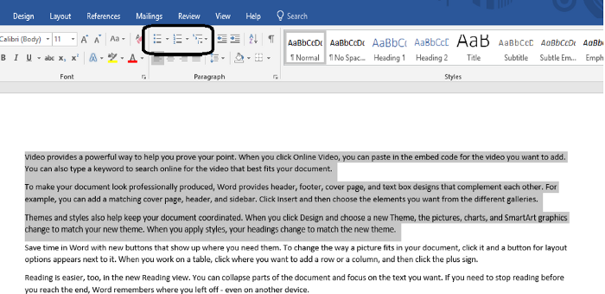

That’s it you are done.

**2.Indenting:**

Same procedure is for indenting as well.

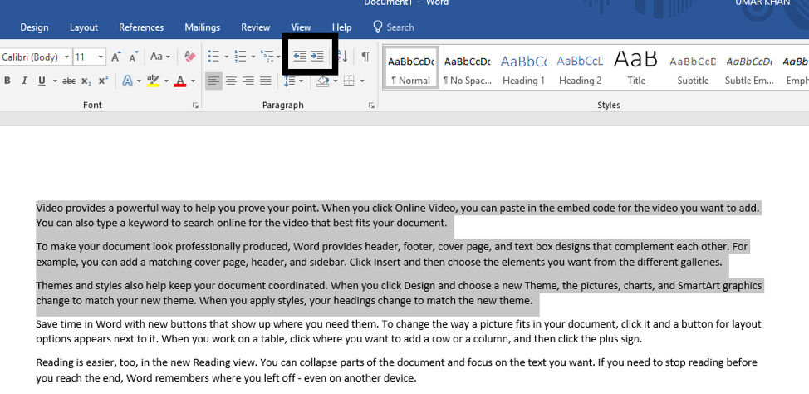

Select paragraphs

Then click on the indenting options i’e left or right in that direction you want to indent the text.

**3.Aligning:**

Select the content or text to be aligned.

Alignment provides four options

* Left
* Right
* Center
* And justify

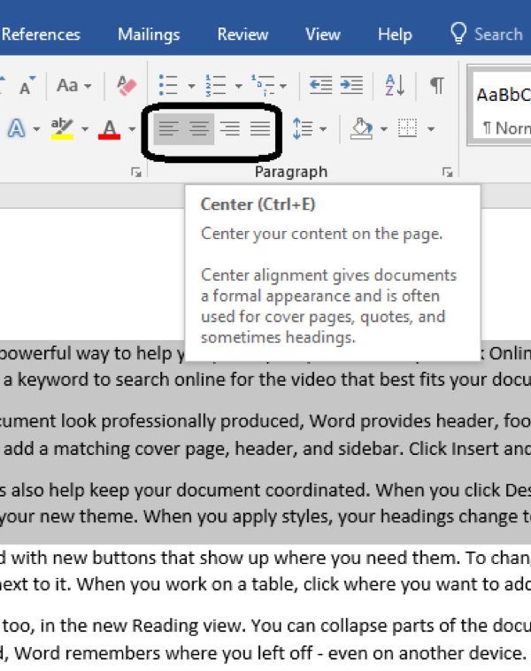

Click on any among the four it will be done.

**4.Shading:**

Select the passages or paragraphs as we did before.

Then go to shading option and click on it.

Select the color as per requirement say blue.

Click on it. You are done.

The selected text will be highlighted in blue.

**STYLES DIALOG BOX:**

#### To apply a style:

1. Select the text you want to format, or place your cursor at the beginning of the line.

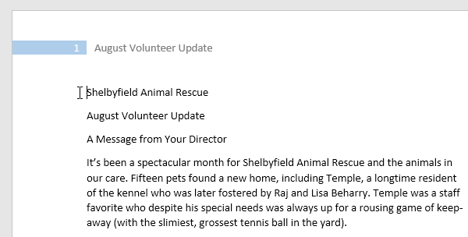

1. In the **Styles** group on the **Home** tab, click the **More** drop-down arrow.

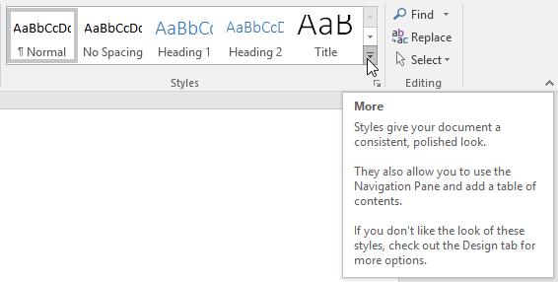

1. Select the **desired style** from the drop-down menu.

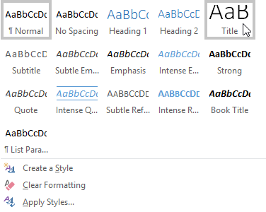

1. The text will appear in the selected style.

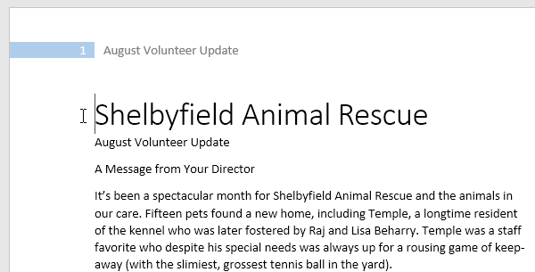

With the uses of style dialog box we can give heading to important topic or title of topic. There are different format of heading so with these format we can change the heading style of or title or important info.

**EDITING DIALOG BOX:**

Editing box is used for find and replace text in document.

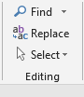

* 1. Click on find option and search for word which you want to find.
  2. For example I want to search “text” in document.

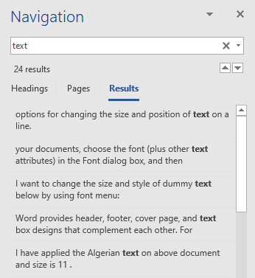

1. This will find the text and give result us for our searching.

**Replace:**

* 1. Click on replace option for replacing word with another word.
  2. For example, I want to replace text word with message, it is shown in figure below there.

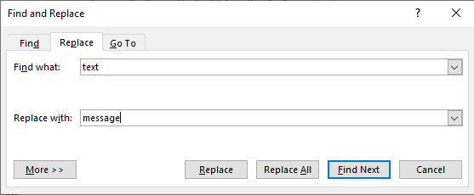

And then click on find next option to complete the steps.

Lab # 04

**INSERT TAB:**

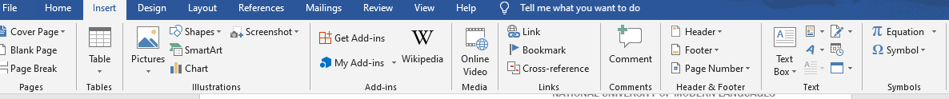

The Insert tab contains various items that you may want to insert into a document.  These items include such things as tables, word art, hyperlinks, symbols, charts, signature line, date & time, shapes, header, footer, text boxes, links, boxes, equations and so on.

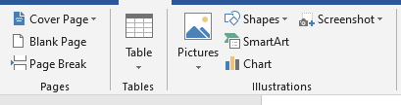

Pages:

1. From the insert dialog box first we can insert cover page in start of document by clicking on cover page.

# Insert a blank page

To put a blank page into your Word document, place the cursor where you want the new page to begin and then click **Insert** > **Blank Page**. The blank page opens, ready for whatever you want to add.

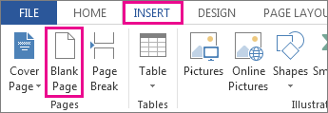

Another option when you need a little space is to insert a page break. The difference is that **Insert** > **Blank Page** puts an entire blank page into your document, and **Insert** > **Page Break** doesn’t. Instead, it pushes whatever comes after the break to the top of the next page.

Break page:



1. Page break option is used for to break the page to next page.
2. When you click on the page beak option it provides another page and jumped to next page.

**Tables:**



1. Tables dialog box is used to insert table in document.
2. To insert table then click on table option that appears in a table dialog box.
3. Then choose how many rows and columns you want to insert in table.
4. For example I want to insert 3 columns and 5 rows then:

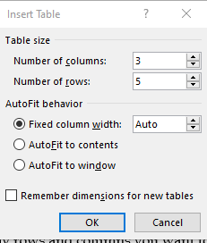

|  |  |  |
| --- | --- | --- |
| Name | Roll no | Department |
| Irfan | 2433 | CS |
| Uzair | 2447 | CS |
| Zohaib | 2444 | CS |
| Hassan | 2442 | CS |

1. For example I have created the table of 3 column and 5 rows.

**Illustrations:**

In addition to inserting and formatting text into your document, Word 2013 also allows you to insert text boxes, lines, shapes, images, ClipArt, and WordArt, through its image and drawing features. In this section, we will cover the diversity of these illustration functions in Word, as well as how to use them most effectively.

The first step to inserting pictures or drawings in Word is accessing the **Illustrations**icon group in the ribbon menu.

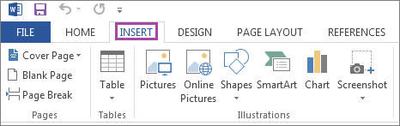

## **Adding Pictures:**

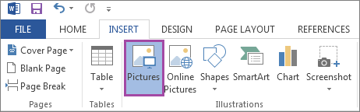

1. To insert a picture saved on your hard disk, first select the **Pictures** icon from the ribbon men.

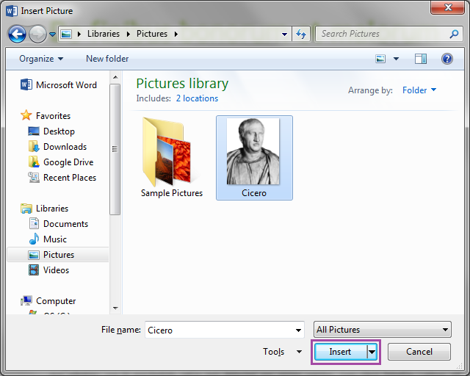

1. A new window will appear, prompting you to indicate where on the hard disk the picture you want to insert is located. Once you have located the picture, click on the **Insert**button.

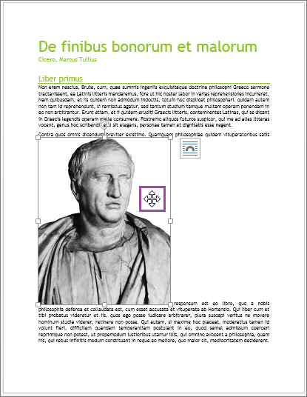

1. Once the picture has been inserted, move the cursor anywhere over it, clicking and dragging to move it to where you want it on the page.

## **Inserting ClipArt**

If your network or internet connection is active, you can insert ClipArt from Microsoft's online database.

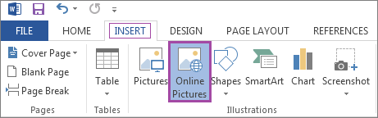

1. To insert ClipArt, click on the **INSERT**tab, and select **Online Pictures**.

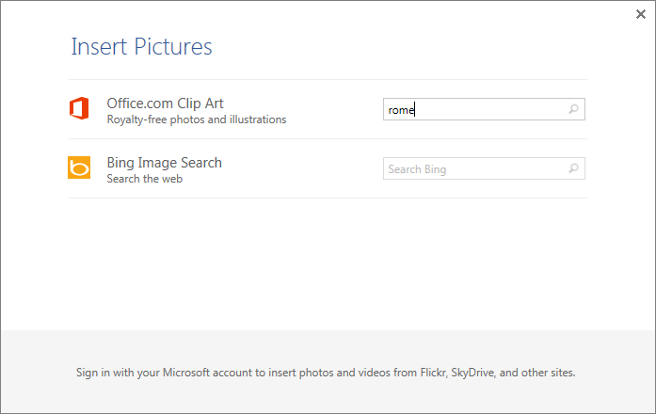

1. In the dialog box, type in a subject in the **Office.com Clip Art**search field, and press **Enter.**

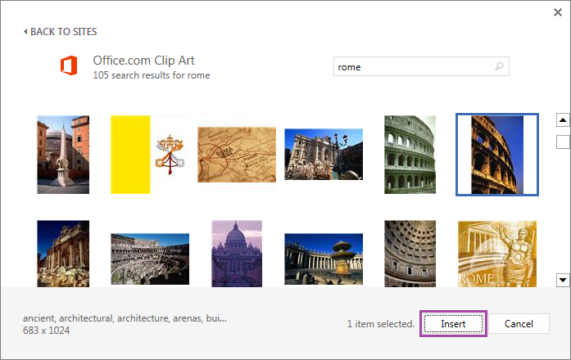

1. Select the ClipArt image you want from the list of results that appear, and click **Insert**to add it to your document. You can move, re-size, format, or change text wrapping using the same method as pictures added from your hard drive.

## **Inserting Shapes**

1. To insert a shape, click on the **INSERT**tab. Clicking on **Shapes**, select the desired shape from the drop-down menu. Because this option is used quite frequently, we will select**multiple shapes**under **Basic Shapes**, for the purpose of this tutorial.

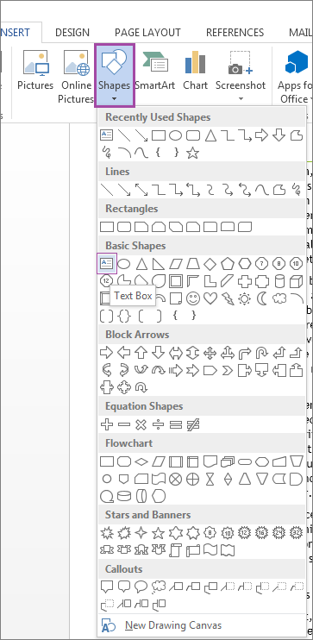

1. For we want to select triangle, arrow and rectangular shapes for trial.

MULTIPLE SHAPES

## **SmartArt**

In addition to the Text Box feature, Word also includes a feature called **SmartArt**, which allows you to represent ideas in diagram format.

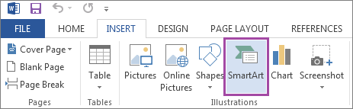

1. To insert SmartArt, click on the **INSERT**tab, and select **SmartArt** under the **Illustrations**icon group on the ribbon menu.

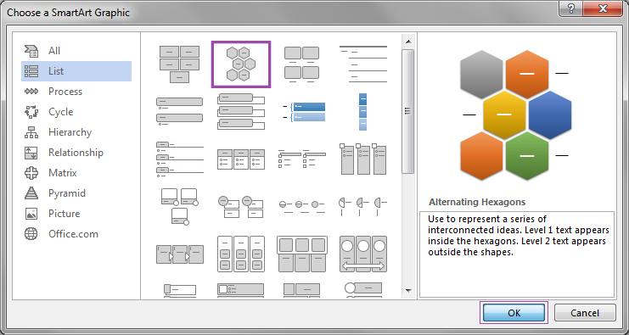

1. A window will appear, prompting you to pick the kind of SmartArt graphic you would like to use. After selecting one from among the many options available, click **OK**.

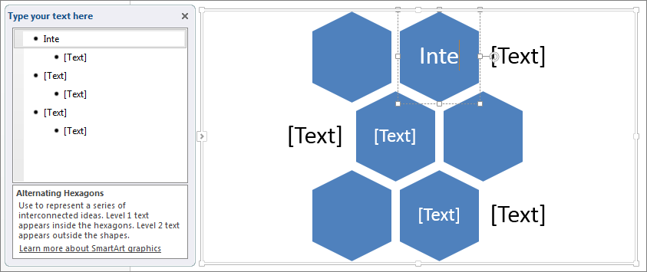

1. Format the text of the SmartArt graphic either by clicking on the text, or using the outline to the left of the graphic.
2. For example we want to add some different smart art so by following above given steps;

Here we have created the cycle smart art .

## **Charts:**

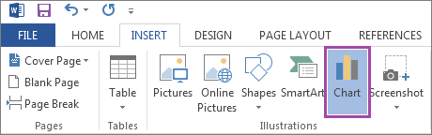

1. To insert a chart, click on the **INSERT**tab, selecting **Chart**under the **Illustrations**icon group on the ribbon menu.

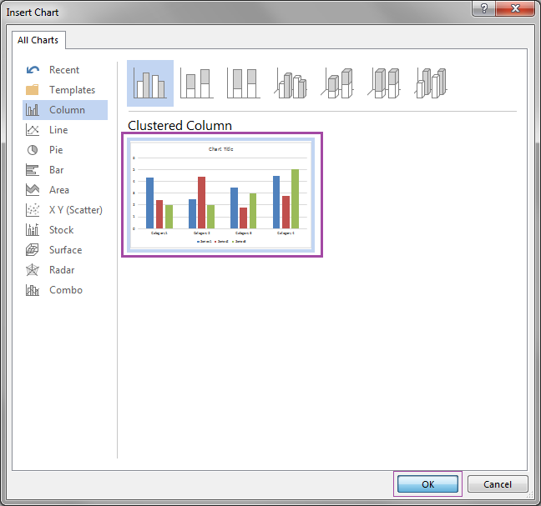

1. Select what kind of chart you wish to insert, and then click **OK**.

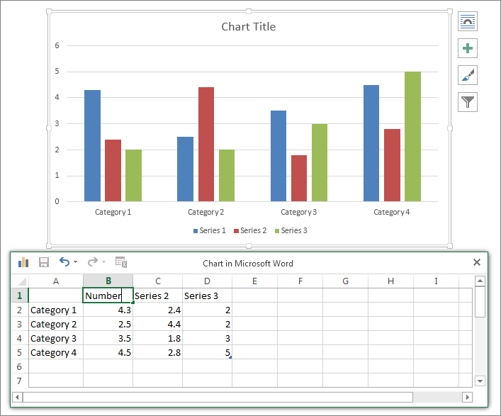

1. Once the chart has been inserted, you can use the Excel popup window to edit the different fields. To format anything on the chart, simply click on what you would like to change. You may also use the ribbon menu. If you would like move or re-size your chart, or to change the way the surrounding text wraps around it

Here in above I have inserted the chart of population for demo purpose.

## **Screenshots**

A feature in Word is the ability to insert screenshots into your document, using the program rather than simply the print screen function of Windows.

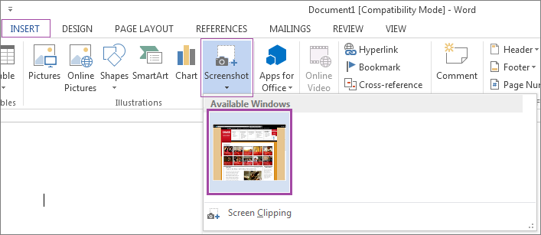

To insert a screenshot into your document, click on the **INSERT**tab, selecting **Screenshot**under the **Illustrations**icon group on the ribbon menu. A drop-down menu will appear, showing you screenshots of all your open windows. To select one, click on it. Once it is inserted, you can further format it. If you would like move or re-size the screenshot, or to change the way the text wraps around it.

LAB #05

#### Header & Footer

|  |
| --- |
|  |

**Header** - Drop-Down. This displays a gallery of the built-in headers. The drop-down also contains the commands Edit Header, Remove Header and Save Selection to Header Gallery. Also appears on the Header and Footer Tools - Design contextual tab.  
**Footer** - Drop-Down. This displays the gallery of built-in footers. The drop-down also contains the commands Edit Footer, Remove Footer and Save Selection to Footer Gallery. Also appears on the Header and Footer Tools - Design contextual tab.  
**Page Number** - Drop-Down. The drop-down contains the commands: Top of Page, Bottom of Page, Page Margins, Current Position, Format Page Numbers and Remove Page Numbers. The first four commands all display galleries of built-in page number options and allow you save your own to the gallery. The Format Page Numbers command displays the familiar "Page Number Format" dialog box.

1. Click on **either header or footer** drop-down menu in the **Header & Footer section.**
2. A Header or Footer drop-down menu will display on the screen with a list of built-in Header or Footer options. Select your desired option from the Built-in list.

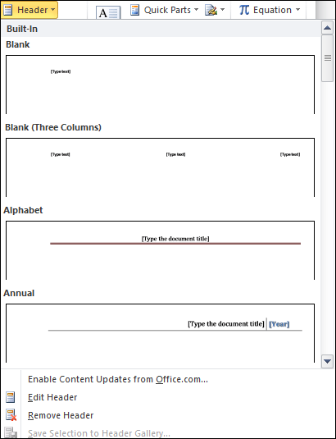

Type your desired information into the header or footer section.

Header is inserted into the top of pages while footer is inserted at the bottom of pages.

**TEXT :**

**TEXT BOX:**

* Select the Insert tab
* Locate the Text group
* Click the Text Box button
* It displays Built-In text box menu and an option to draw table
* With a left click select the desired text box format from the menu

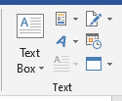

A drop-down menu will appear. Select **Draw Text Box**.

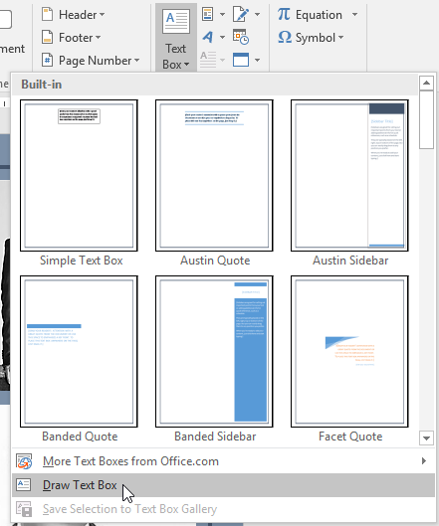

Click and drag anywhere on the document to create the text box.

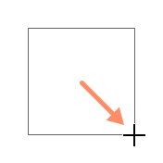

The insertion point will appear inside the text box. You can now type to create text inside the text box.

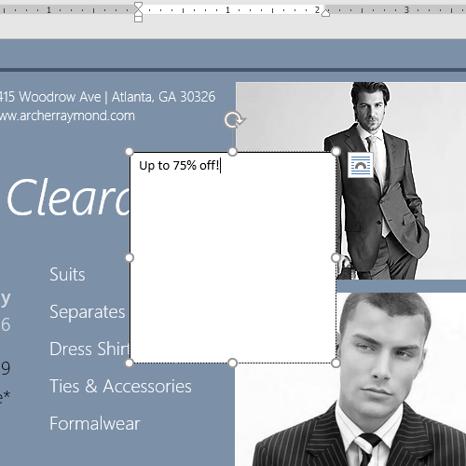

**WordArt**

To insert decorative text into the document, click this button. A gallery of different styles of WordArt will display. Click the desired format to create the WordArt image.

**SIGNATURE:**

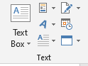 **SIGNATURE**

This button is used to insert a digital signature line into a document that indicates who must sign the document. A Digital ID must be obtained before this feature can be used.

Date and Time:



To insert the date and time into a document, click this button. The dialog box that appears displays several date and time formats. This option is used to insert date and time into the document.

***Symbols:***

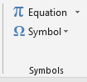

Symbols:

Click this button to insert a symbol such as a copyright or trademark into the document. For example, (₧↨±©®™).

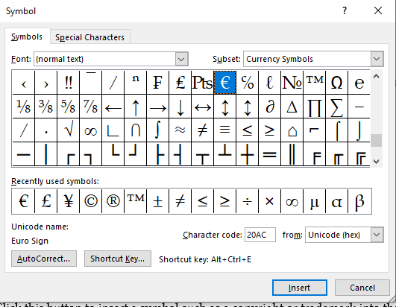

To insert any symbol first click on symbol and then click on insert option as shown in figure above.

Equation:

This button is used to insert a mathematical equation into a document. The equation tools ribbon will appear when the button is clicked. This ribbon is used to create the equation. A list of common equations is also available.

List of equation is:

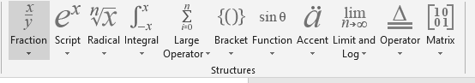

Comments:

A comment in a Word document is useful when needing to make note of something that requires attention or needs fixed, or provide additional information to others reading the document.

1. On the Insert tab, click the **Comment** option in the Comments group.
2. The new comment is added to the document. On the right side of the document, the comment is visible. Click in the comment to enter the desired text.

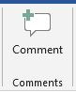

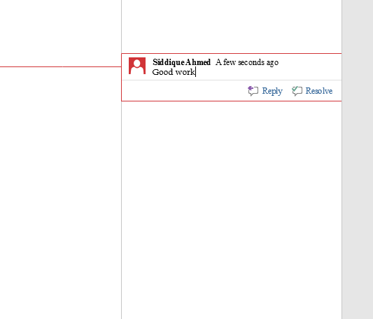

here I inserted the comment in my document for any text which I want.

Edit a document:

1. In the Microsoft Word document, find the comment you want to edit.
2. The comment should be visible on the right side of the document. **Click in the comment** and edit the text for that comment.

## Delete a comment

To delete a comment in a Microsoft Word document, follow the steps below.

1. In the Microsoft Word document, find the comment you want to delete.
2. Using your mouse, place the text cursor over the comment on the right side of the document.
3. [Right-click](https://www.computerhope.com/jargon/r/righclic.htm) with your mouse and select the **Delete Comment** option in the pop-up menu that appears.

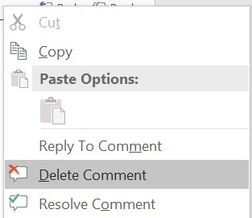

**Lab# 06**

### Design Tab

#### Document Formatting

|  |
| --- |
|  |

**Themes** - The drop-down contains the commands: Built-in, More Themes on Microsoft Office Online, Browse for Themes and Save Current Theme. The built-in themes are: Office, Apex, Aspect, Civic, Concourse, Equity, Flow, Foundry, Median, Metro, Module, Opulent, Oriel, Origin, Paper, Solstice, Technic, Trek, Urban and Verve. Tooltip indicates the current theme. The default theme is "Office". Tooltip indicates the current theme. Quick Access to more themes saved down on Microsoft Office Online. Default theme is "Office". Changes the overall design of the entire document in colours, fonts and effects. This drop-down has an additional command not found in Excel or PowerPoint which is "Reset to Theme from Template".  
**Style Set** - Change the look of your document by choosing a new style set. Style sets change the font and paragraph properties of your entire document.  
**Colors** - Drop-Down. Displays a list of all the available colors and lets you change the color component of the active theme.  
**Fonts** - Drop-Down. Displays a list of all the available fonts and lets you change the font component of the active theme.  
**Paragraph Spacing** -. Drop-Down. Quickly change the line and paragraph spacing in your document. The drop-down contains the commands: No Paragraph Space, Compact, Tight, Open, Relaxed, Double, Custom Paragraph Spacing.  
**Effects** -. Drop-Down. Displays a list of all the available effects and lets you change the effect component of the active theme. The drop-down contains the commands: Office, Apex, Aspect, Civic, Concourse, Equity, Flow, Foundry, Median, Metro, Module, Opulent, Oriel, Origin, Paper, Solstice, Technic, Trek, Urban and Verve.  
**Set As Default** - Use the current look for all new documents.

#### Page Background

|  |
| --- |
|  |

**Watermark** - Drop-Down. The drop-down contains the commands: Custom Watermark, Remove Watermark and Save Selection to Watermark Gallery.  
**Page Color** - Drop-Down. Lets you change the background colour of the page. Displays the full theme colour palette.  
**Page Borders** - Displays the "Border and Shading" dialog box.

**LAB # 07**

LAYOUT

PAGE SETUP:

A **margin** is the **space** between the text and the edge of your document. By default, a new document's margins are set to **Normal**, which means it has a one-inch space between the text and each edge. Depending on your needs, Word allows you to change your document's margin size.

To format page margins:

1. Select the **Layout** tab, then click the **Margins** command.

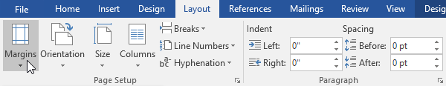

1. A drop-down menu will appear. Click the **predefined margin size** you want.

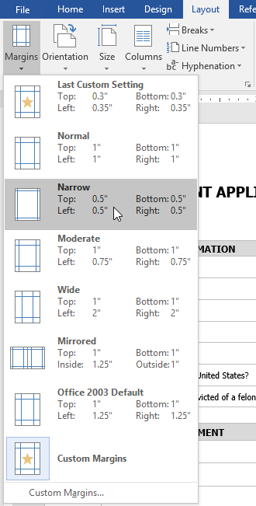

1. The margins of the document will be changed.

#### To change page orientation:

1. Select the **Layout** tab.
2. Click the **Orientation** command in the Page Setup group.

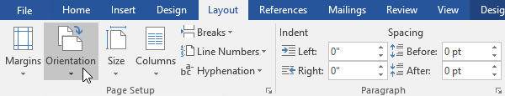

1. A drop-down menu will appear. Click either **Portrait** or **Landscape** to change the page orientation.

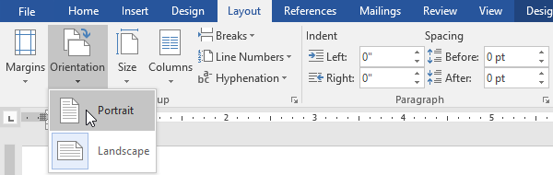

1. The page orientation of the document will be changed.

### Page size:

By default, the **page size** of a new document is 8.5 inches by 11 inches. Depending on your project, you may need to adjust your document's page size.

To change the size of page:

1. Select the **Layout** tab, then click the **Size** command.
2. A drop-down menu will appear. The current page size is highlighted. Click the desired **predefined** **page size**.

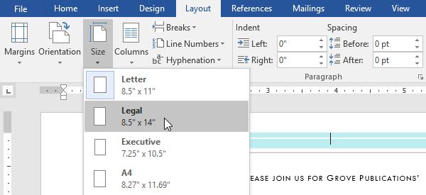

1. The size of page will be changed.

**Column:**

Column option is used to insert column like in newspaper and in other magazines.

1. Select the text you want to format.

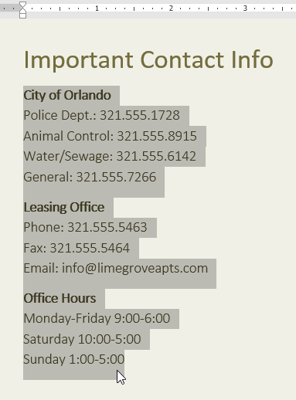

1. Select the **Layout** tab, then click the **Columns** command. A drop-down menu will appear.
2. Select the number of columns you want to create.

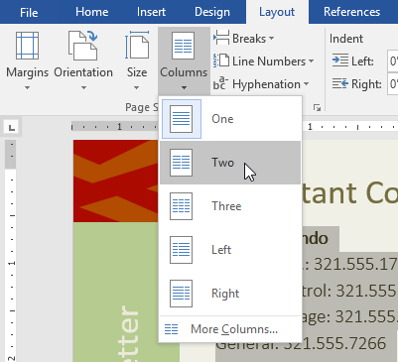

1. The text will format in columns.

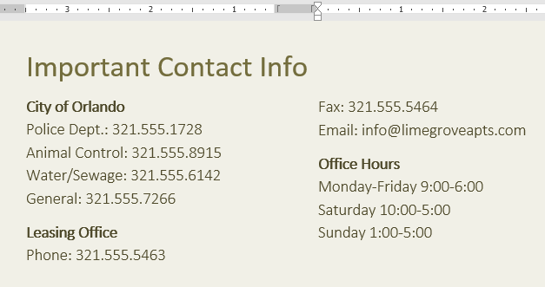

**Breaks & line numbers:**

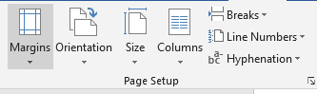

Break option is used to break the page and jumped to next page.

And line numbers option is used to insert line numbers in your document and is useful for to count lines.

**Paragraph:**

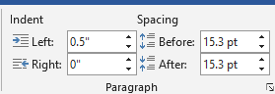

**Indent:**

Indent option is used for to move your paragraph to left or right from its original position. It can be moved to left or right as you want to change.

**Spacing:**

Spacing option is used to insert space between your paragraph when we use before option it makes spacing between two paragraphs equal and if we use after option then it repels two paragraphs against each other.

**Lab#08: References**

**Table of contents:**



1. In this tab first of all there is table of contents option it is used for insert table of contents in document e.g in first page of every book there is also table of content which we can make in MS word.

**Table of Contents** - Drop-Down. Provide an overview of your document by adding a table of contents. The drop-down contains the commands: Built-in, Insert Table of Contents and Save Selection to Table of Contents Gallery.  
**Add Text** - Drop-Down. The drop-down contains the commands: Do Not Show in Table of Contents, Level 1, Level 2 and Level 3.  
**Update Table** - Updates the table of contents so that all the entries refer to the correct page numbers.

### Create the table of contents

1. Put your cursor where you want to add the table of contents.
2. Go to **References** > **Table of Contents**. and choose an automatic style.

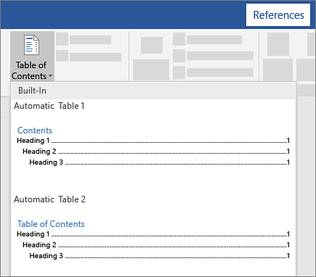

1. If you make changes to your document that affect the table of contents, update the table of contents by right-clicking the table of contents and choosing **Update Field**.

## To update your table of contents manually, see [Update a table of contents](https://support.microsoft.com/en-us/office/update-a-table-of-contents-6c727329-d8fd-44fe-83b7-fa7fe3d8ac7a). Add a Table of Contents

Regardless of the size of your document, using a table of contents can direct the reader to exactly where they need to be. In addition to making the document more reader-friendly, a table of contents also makes it easier for the author to go back and add or remove content if necessary.

By default, Word generates a table of contents using the first three built-in heading styles (Heading 1, Heading 2, and Heading 3). To apply heading styles, select the particular style from the “Home” tab. If you’re not happy with the types of heading styles available, you can [change the default heading style](https://www.howtogeek.com/399978/how-to-change-heading-styles-in-ms-word/).

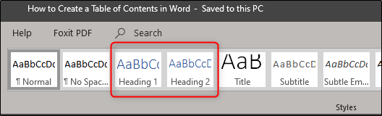

You can manage this in two different ways. You can either apply the heading styles to each section after you’ve finished the document, or you can add them as you go.

Once you’ve applied your heading styles, it’s time to insert your table of contents.  The first thing you need to do is put the cursor where you want the table of contents to appear. Once ready, head over to the “References” tab and select “Table of Contents.”

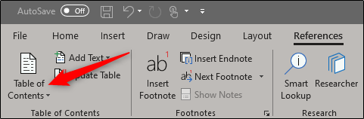

A drop-down menu will appear. Here, you can choose between the three different built-in tables.

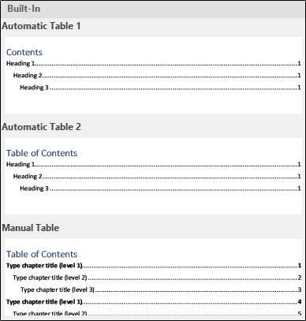

The only difference between Automatic Table 1 and 2 is the title, which is “Contents” and “Table of Contents,” respectively. Selecting either Automatic Table 1 or 2 will create the table of contents using the names of the headings.

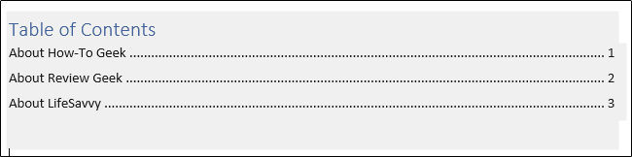

If you chose the “Manual Table” option from the “Table of Contents” drop-down menu, then it will insert a template for you that you will need to edit yourself.

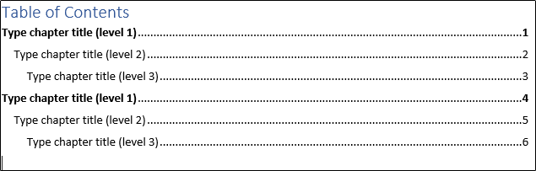

You may notice in this table of contents that there are sub-levels. Each level represents a heading style in your document. So if you use the automatic table and you want sub-levels in your ToC, you will need to use heading 1 for level 1, heading 2 for level 2, and heading 3 for level 3.

If you want your table of contents to go deeper than the top three heading styles, you can do that, too. On the dropdown menu when you click the “Table of Contents” button, choose the “Custom Table of Contents” option.

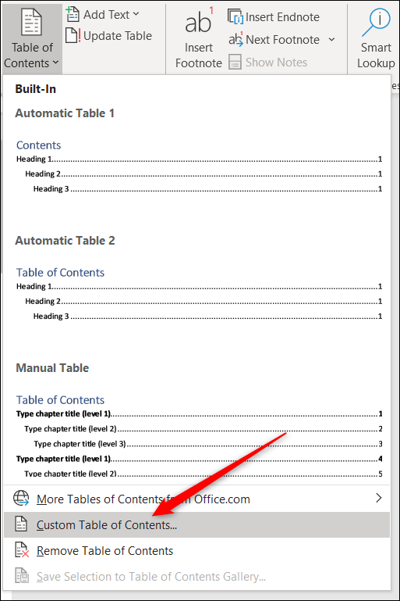

In the Table of Contents window that opens, click the “Options” button.

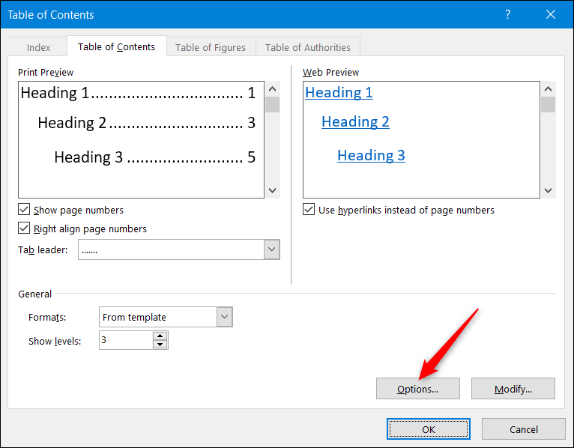

In the Table of Contents Options window, next to each available style you want to use (these are Word’s built-in styles starting with Heading 4), type the TOC level you wish to use. Click “OK” when you’re done.

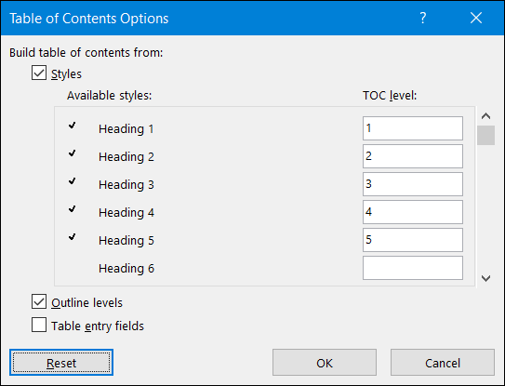

## Updating the Table of Contents

If you ever need to add or remove a section from your document, you can easily update the table of contents to reflect those changes. To update your table of contents, select it, click “Update Table” on the pop-up menu that appears, and then choose whether you want to update only the page numbers or the entire table. Click “OK” to apply the changes.



Your table of contents will now be updated.

## Removing the Table of Contents

Removing the table of contents is simple. All you need to do is select it and then click the arrow on the menu that appears.

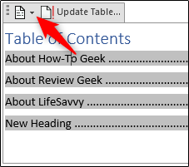

At the bottom of the drop-down menu, select “Remove Table of Contents.”

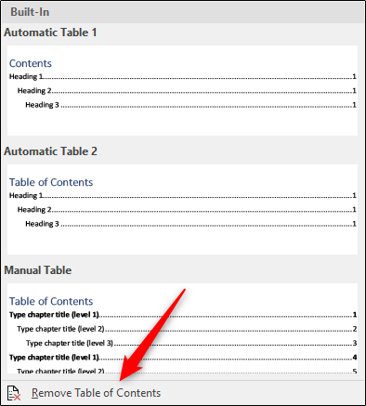

Your table of contents will now be removed from your document.

**Footnotes**

You can quickly display the "Footnote and Endnote" dialog box by clicking on the dialog box launcher in the bottom right corner of this group.

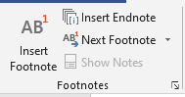

**Insert Footnote** - (Alt + Ctrl + F). Inserts a footnote at the current position. Footnotes are automatically renumbered as you move text around the document.  
**Insert Endnote** - (Alt + Ctrl + D). Inserts an endnote at the end of the document. End notes are always placed at the end of a document.  
**Next Footnote** - Button with Drop-Down. The button moves to the next footnote. The drop-down provides the commands Next Footnote, Previous Footnote, Next Endnote and Previous Endnote.  
**Show Notes** - Shows where footnotes and endnotes are located

Citations & Bibliography

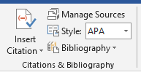

**Insert Citation** - Drop-Down. The drop-down contains the commands: Add New Source, Add New Placeholder and Search Libraries.  
**Manage Sources** - Displays a list of all the sources cited in the active document.  
**Style** - Choose the style of citation to use in the document.  
**Bibliography** - Drop-Down. The drop-down contains the commands: Insert Bibliography and Save Selection to Bibliography Gallery.

**Caption**

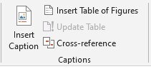

**Insert Caption** - Insert a caption below a picture or graphic to provide a short description.  
**Insert Table of Figures** - Add a list of captioned objects and their page numbers.  
**Update Table** - Updates the table of figures to include all of the entries in the document.  
**Cross-reference** - Displays the "Cross-reference" dialog box allowing you to insert cross-referencing into your document, for example: turn to page 3 or please refer to page 12. Cross references are inserted as hyperlinks.

The **Insert Caption** feature in Word does most of the heavy lifting for you, when you want to add a caption to a picture. For other Office apps, it’s a little trickier and involves [adding a text box](https://support.microsoft.com/en-us/office/add-copy-or-delete-a-text-box-4d968daa-5c86-48f2-88fa-b65871966017) and then [grouping the text box and picture](https://support.microsoft.com/en-us/office/group-or-ungroup-shapes-pictures-or-other-objects-a7374c35-20fe-4e0a-9637-7de7d844724b). And if you have multiple pictures in a series, you’ll have to manually track and increase the numbers.

## **Word**

1. Click the picture you want to add a caption to.
2. Click **References** > **Insert Caption**.

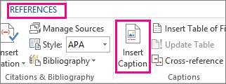

1. To use the default label (Figure), type your caption in the **Caption** box.

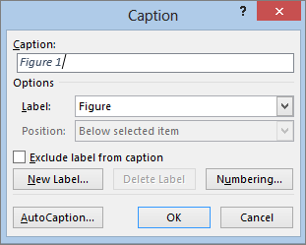

**Index**

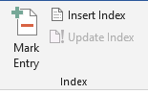

**Mark Entry** - (Alt + Shift + X). Marks the currently selected text so it will appear in the index of the document.  
**Insert Index** - Add an index listing key words and page numbers they appear on.  
**Update Index** - Updates the index table.

Table of authorities:

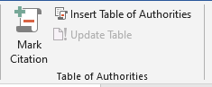

**Mark Citation** - (Alt + Shift + I). Adds the currently selected text so it will appear in the table of authority.  
**Insert Table of Authorities** - Inserts a table of authorities for cases, statutes and other authorities in the document.  
**Update Table** - Updates the table of authorities to include all the citations in the document.

**Lab# 09:**

### Mailings Tab

### This tab contains everything needed to complete a successful mail merge

#### Create

|  |
| --- |
|  |

**Envelopes** - Lets you create and print envelopes.  
**Labels** - Lets you create and print labels.

#### Start Mail Merge

|  |
| --- |
|  |

**Start Mail Merge** - Drop-Down. The drop-down contains the commands: Letters, E-mail Messages, Envelopes, Labels, Directory, Normal Word Document and Step-by-Step Mail Merge Wizard. Creates a from letter which you intend to email or print multiple times sending each copy to a different recipient. Displays the "New Address List" dialog box.  
**Select Recipients** - Drop-Down. The 3 options are from step 3 of the wizard. The drop-down contains the commands: Type New List, Use Existing List and Select from Outlook Contacts. Type New List displays the "New Address List" dialog box. You will have to save this list as a Microsoft Office Address List (.mdb).  
**Edit Recipient List** - Displays the "Mail Merge Recipients" dialog box allowing you to change or filter the list of recipients.

#### Write & Insert Fields

These commands are only available when you are in a mail merge document.

|  |
| --- |
|  |

**Highlight Merge Fields** - Highlights all the fields in the active document that have been inserted. This makes is easy to see what will be replaced.  
**Address Block** - Displays the "Insert Address Block" dialog box. This allows you to customize how the address will be inserted.  
**Greeting Line** - Displays the "Insert Greeting Line" dialog box. Lets you add a greeting line to your document.  
**Insert Merge Field** - Button with Drop-Down. The button displays the "Insert Merge Field" dialog box. The drop-down allows you to quickly insert a merge field just by clicking on it in the list and contains the commands: Title, First_Name, Last_Name, Company_Name, Address_Line_a, Address_Line_2, City, State, Zip_Code, Country_or_Region, Home_Phone, Work_Phone, Email_Address.  
**Rules** - Drop-Down. Lets you add decision making rules to the mail merge. The drop-down contains the commands: Ask, Fill-in, If-Then-Else, Merge Record, Merge Sequence, Next Record, Next Record If, Set Bookmark, Skip Record If.  
**Match Fields** - Displays the "Match Fields" dialog box allowing you to match the required fields with the recipients list.  
**Update Labels** - Only enabled when creating labels. Updates all the labels in the document to be consistent with the first label.

#### Preview Results

|  |
| --- |
|  |

**Preview Results** - This is disabled when there are no fields in your document. Toggles the merged fields in your document with actual data from your recipient list.  
**First Record** - View the first record in the recipient list.  
**Previous Record** - View the previous record in the recipient list.  
**Go to Record** - View a specific record in the recipient list.  
**Next Record** - View the next record in the recipient list.  
**Last Record** - View the last record in the recipient list.  
**Find Recipient** - Displays the "Find Entry" dialog box to search for a particular text entry.  
**Auto Check for Errors** - (Alt + Shift + K). Displays the "Checking and Reporting Errors" dialog box. This allows you to simulate the mail merge and to specify how to handle any errors that occur during mail merge. You can even simulate the merge and report errors in a new document.

#### Finish

|  |
| --- |
|  |

**Finish & Merge** - Drop-Down. The drop-down contains the commands: Edit Individual Documents, Print Documents and Send E-mail Messages.

**Lab#10**

### Review Tab

This tab provides commands previously found on the Reviewing toolbar, Comments toolbar, Protection toolbar and Tools menu.

#### Proofing

|  |
| --- |
|  |

**Spelling & Grammar** - Displays the "Spelling and Grammar" dialog box. This allows you to check the spelling and grammar in the active document.  
**Research** - Toggles the display of the Research task pane. Same as Excel.  
**Thesaurus** - Toggles the display of the Research task pane defaulting the research service to the thesaurus. Same as Excel.  
**Translate** -. Toggles the display of the Research task pane defaulting the research service to the translation.  
**Translation ScreenTip** - The drop-down contains the commands:  
**Set Language** - This displays the "Language" dialog box. This dialog box can also be displayed by clicking on the language indicator on the status bar.  
**Word Count** - This displays the "Word Count" dialog box displaying the document statistics. This replaces the Word Count toolbar. This dialog box can also be displayed by clicking on the word count indicator on the status bar.

#### Accessibility

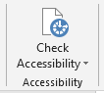

|  |
| --- |
|  |

**Check Accessibility** -

#### Language

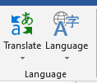

|  |
| --- |
|  |

**Translate** - Displays the Research task pane. This drop-down contains the commands: Translate Document, Translate Selected Text, Mini Translator and Choose Translation Language.  
**Language** - This drop-down contains the commands: Set Proofing Language and Language Preferences. Set Proofing Language display the "Language" dialog box. Language Preferences displays the "Options" dialog box, Language Tab.

#### Comments

|  |
| --- |
|  |

**New Comment** - (Shift + F2). Inserts a comment at the active cell. This command does not change to Edit Comment when a comment is selected like it does in Excel.  
**Delete** - Button with Drop-Down. Deletes the selected comment. The button deletes the comment in the active selection. The drop-down contains the commands: Delete All Comments Shown and Delete all comments in Document. This is disabled when the document does not contain any comments.  
**Previous** - Goes to the previous comment in the active document. This is disabled when the document does not contain any comments.  
**Next** - Goes to the next comment in the active document. This is disabled when the document does not contain any comments.  
**Show Comments** -

#### Tracking

|  |
| --- |
|  |

**Track Changes** - (Ctrl + Shift + E). Button with Drop-Down. The button is the Track Changes command from the Reviewing toolbar that ???. The drop-down is the old (Show > Options) from the Reviewing toolbar and contains the commands Track Changes, Change Tracking Options and Change User Name. Change Tracking Options displays the Track Changes Options dialog box. Change User Name displays the Word Options dialog box (Popular tab).  
**Balloons** - Lets you choose how to display the revisions either in the margin or in the actual document. The drop-down contains the commands: Show Revisions in Balloons, Show all Revisions Inline and Show Only Comments and Formatting in Balloons.  
**Display for Review** - Drop-Down. The drop-down contains the commands: Simple Markup (previously Final Showing Markup), All Markup (previously Showing Markup), No Markup (previously Final) and Original.  
**Show Markup** - Drop-Down. The drop-down contains the commands: Comments, Ink, Insertions and Deletions, Formatting, Markup Area Highlight.  
**Reviewing Pane** - Button with Drop-Down. The button toggles the display of the Reviewing pane. The drop-down contains the commands: Reviewing Pane Vertical and Reviewing Pane Horizontally. There is now also summary information at the top of the pane.

#### Changes

|  |
| --- |
|  |

**Accept** - Button with Drop-Down. The button is the Accept and Move to Next command which accepts the current change and moves to the next proposed change. The drop-down contains the commands: Accept and Move to Next, Accept Change, Accept all Changes Shown and Accept all Changes in Document. This drop-down is disabled when the document is protected.  
**Reject** - Button with Drop-Down. The button is the Reject and Move to Next command which rejects the current change and moves to the next proposed change. The drop-down contains the commands: Reject and Move to Next, Reject Change, Reject all Changes Shown and Reject all Changes in Document. This drop-down is disabled when the document is protected.  
**Previous** - Moves to the previous revision in the active document. This is a bit confusing as it does exactly the same as the Previous in the comments group ??  
**Next** - Moves to the next revision in the active document.

#### Compare

|  |
| --- |
|  |

**Compare** - The drop-down contains the commands: Compare and Combine. The Compare command lets you compare two versions of the same document and displays the "Compare Documents" dialog box. The Combine command lets you combine revisions from multiple authors and displays the "Combine Documents" dialog box. This drop-down is disabled when the document is protected.  
**Show Source Documents** - Lets you choose which source documents to show. You can show the original, the revised or both. The drop-down contains the commands:

#### Protect

|  |
| --- |
|  |

**Block Authors** - Prevent others from making changes to the selected text.  
**Restrict Editing** - Toggles the display of the Restrict Editing task pane. This task pane was called "Restrict Formatting and Editing" in 2010 and was called "Protect Document" in 2003.  
**Protect Document** - The drop-down contains the commands: Unrestricted Access, Restricted Access, Manage Credentials.  
All these options will be disabled if your document is the basis of a mail merge?? - Similar to Protect workbook drop-down in Excel.  
This button changes into a drop-down when you are using Information Rights Management (IRM). The only Office suite to include IRM though is Professional Plus, Ultimate and Enterprise. In order to use IRM you need to have Microsoft Windows Rights Management Service (RMS) for windows server.

#### Ink

|  |
| --- |
|  |



**Start Inking** -

### View Tab

This tab provides commands previously found in the View menu and Window menu.

#### Views

This group contains all the commands relating to the different ways you can view your documents.

|  |
| --- |
|  |

**Read Mode** - this was called Full Screen Reading. Maximizes the Word window on the screen and removals all toolbars etc to allow easy reading.  
**Print Layout** - Displays the document as it would appear if printed and is the default view.  
**Web Layout** - Displays the document as it would appear as a web page.  
**Outline** - Displays the document as an outline is displays the Outlining contextual tab.  
**Draft** - Displays the document in draft mode allowing for quick editing. When using this view certain aspects of the document are not visible, for example any headers or footers.

#### Immersive

|  |
| --- |
|  |

**Learning Tools** -

#### Show

|  |
| --- |
|  |

**Ruler** - Toggles the display of the ruler(s).  
**Gridlines** - Toggles the display of gridlines.  
**Navigation Pane** - (Added in 2010). Toggles the display of the Navigation task pane. This is a combination of the Find, Document Map and Thumbnails..

#### Zoom

Everything relating to adjusting the display percentage of the active document. There is also a new zoom slider in the bottom right corner next to the status bar.

|  |
| --- |
|  |

**Zoom** - Displays the "Zoom" dialog box. This can also be accessed from the status bar by clicking on the view percentage.  
**100%** - Adjusts the zoom to 100% of its normal size. Lets you quickly return to 100%.  
**One Page** - Adjust the zoom so an entire page fits in the application window.  
**Two Pages** - Adjust the zoom so two entire pages fit in the application window.  
**Page Width** - Adjust the zoom so the width of the page is the same as the width of the application window.

#### Window

Every document you open in Word can be thought of as a window. It is possible to open multiple windows of the same document.

|  |
| --- |
|  |

**New Window** - Lets you create a new window of the active document.  
**Arrange All** - Tile all the open windows side by side on the screen. This will also maximises the application / document to a full screen.  
**Split** - Splits the current window into two parts.  
**View Side by Side** - Displays two documents side by side so they can be easily compared. If you have more than two documents open the "Compare Side by Side" dialog box is displayed so you can choose which document to display next to the active document. allowing you to scroll multiple windows at the same time.  
**Synchronous Scrolling** - Toggles the synchronize scrolling of the two documents that are displayed side by side. This is only enabled when you are viewing two documents side by side.  
**Reset Window Position** - Resets the windows positions so they take up the same amount of space on the screen when two documents are displayed side by side. This is only enabled when you are viewing two documents side by side.  
**Switch Windows** - Drop-Down. Lets you switch between all the currently active documents. This displays all the window / documents that are currently open in the particular session. Previously these were displayed on the Window menu.

#### Macros

|  |
| --- |
|  |

**Macros** - Button with Drop-Down. The button is the View Macros command and displays the "Macros" dialog box. The drop-down contains the commands: View Macros, Record Macro and Pause Recording.  
If you want to edit macros or do anything more complicated then you should have the Developer tab displayed as well.

#### SharePoint

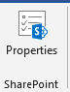

|  |
| --- |
|  |

**Properties** -

**PowerPoint:**

Lab #01

Home tab

#### Slides

|  |
| --- |
|  |

**New Slide** - Button with Drop-Down. The button inserts a new blank Title and Content Slide. The drop-down contains the slides: Title Slide, Title and Content, Duplicate Selected Slides, Slides from Outline and Reuse Slides.  
**Layout** - Drop-Down. The drop-down contains the commands: Title Slide and Title and Content.  
**Reset** - Reset the position, size and formatting of the slide placeholders to their default settings.  
**Section** – it is used for add different section in slides.

#### Drawing

You can quickly ..

|  |
| --- |
|  |

**Shapes** - gallery  
**Arrange** - Drop-Down. The drop-down contains the commands: Bring to Front, Send to Back, Bring Forward, Send Backward, Group, Ungroup, Regroup, Align, Rotate and Selection Pane.  
**Quick Styles** - Drop-Down. The drop-down contains the commands:  
**Shape Fill** - Button with Drop-Down. The button .. The drop-down contains the commands:  
**Shape Outline** - Button with Drop-Down. The button .. The drop-down contains the commands: Theme Colors, Standard Colors, Recent Colors, No Outline, More Outline Colors, Weight, Dashes and Arrows.  
**Shape Effects** - Drop-Down. The drop-down contains the commands: Preset, Shadow, Reflection, Glow, Soft Edges, Bevel and 3D Rotation.

### Insert Tab

#### Slides

|  |
| --- |
|  |

**New Slide** -it is used for insert new slides in document.

#### Tables

|  |
| --- |
|  |

**Table** - Drop-Down. The drop-down displays the commands: Insert Table, Draw Table and Excel Spreadsheet.

#### Illustrations

|  |
| --- |
|  |

**Shapes** - Drop-Down. Consolidated drop-down list of all the shapes including lines, rectangles, basic shapes, block arrows, equation shapes, flow charts, stars and banners and callouts.  
  
**SmartArt** - Displays the "SmartArt Graphic" dialog box which lets you choose from the following different types of smartart: list, process, cycle, hierarchy, relationship, matrix and pyramid.  
**Chart** - Inserts a Microsoft Graph chart . we already discussed about charts in MS word and it is same as in PowerPoint.

#### Links

|  |
| --- |
|  |

**Zoom** -  
**Link** - Displays the "Insert Hyperlink" dialog box. (Previously called the Hyperlink)  
**Action** - Lets you add an action to the currently selected object. Displays the "Action Settings" dialog box.

### Design Tab

#### Themes

|  |
| --- |
|  |

**Themes** - gallery  
**Colors** - Drop-Down.  
**Fonts** - Drop-Down.  
**Effects** - Drop-Down.

# Design in PowerPoint

**Themes**

1. Select the **Design** tab.
2. Select one of the **Themes**.
3. Select one of the **Variants**.

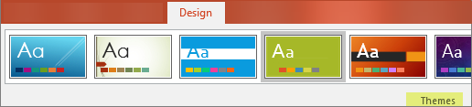

**Use PowerPoint Designer**

1. Insert one or more pictures, a list of items, or a list of dates.
2. The **Designer**panel will open. Select the design you want.

You can also bring up Designer by selecting a picture, and then selecting **Design**> **Design Ideas**.

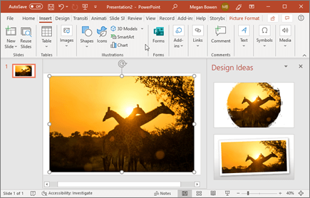

#### Variants

|  |
| --- |
|  |

**Gallery** -

#### Customize

|  |
| --- |
|  |

**Slide Size** -  
**Format Background** -

#### Designer

|  |
| --- |
|  |

**Design Ideas** –

The **Design Ideas** button should be on the right side of your screen, like you see here:

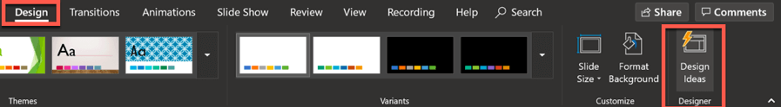

Now, let me give you a quick peek into how this tool works!

Take a look at the screenshots below. I only wrote the word ‘Hello’ on the slide, and look at what the Design Ideas panel on the right side of the screen have come up with!

This is on PowerPoint (Mac):

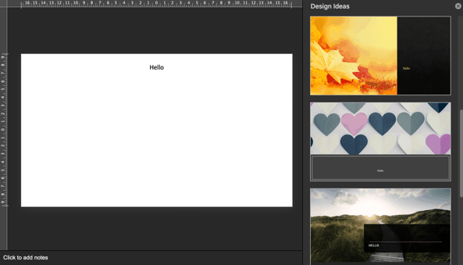

This is on PowerPoint (Windows):

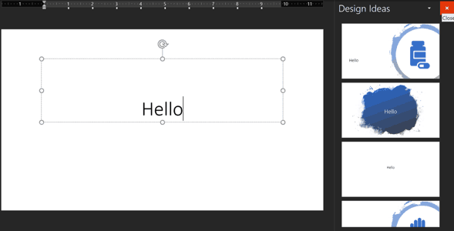

As you can see, the same text (Hello) generated vastly different design ideas. On Mac, the suggestions were visually captivating with beautiful imagery used as background. On Windows, the suggestions were a bit basic to be honest.

This is the beauty of Design Ideas – the suggestions appear to be random. So, if you’re not happy with any of the suggestions, you can give it another try and you’ll get a bunch of new ideas.

So, for the next example, I deleted a couple of characters from the ‘Hello’ text, and then retyped them again. I got the following design ideas next:

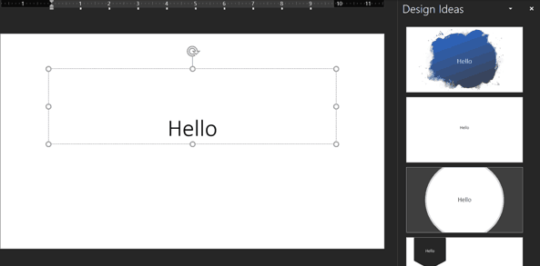

As you can see, it’s still the same text, but different design suggestions. So, if you’re not happy with the suggestions the first time around, try this technique. Perhaps the next round of design ideas may be more to your liking!

### Transitions Tab

#### Preview

|  |
| --- |
|  |

**Preview** - Preview the slide transitions for the active slide.

#### Transition to this slide

|  |
| --- |
|  |

Transition are used to make slide more productive.

**Transition Scheme** - gallery  
**Effect Options** -

**Transitions**

To add a special effect, to transition from one slide to another:

1. Select the slide you want to add a transition to.
2. On the **Transitions** tab, select the effect you want.
3. Select **Effect Options** to change how the transition happens: **From Right**, **From Left**, ...

To undo a transition, select **None**.

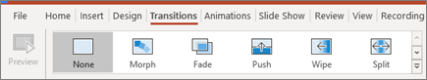

#### To apply a transition:

1. Select the **desired slide** from the **Slide Navigation** pane. This is the slide that will appear **after** the transition.

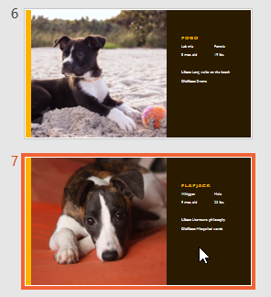

1. Click the **Transitions** tab, then locate the **Transition to This Slide** group. By default, **None** is applied to each slide.
2. Click the **More** drop-down arrow to display all transitions.

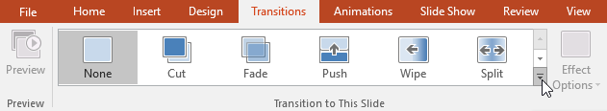

1. Click a**transition**to apply it to the selected slide. This will automatically preview the transition.

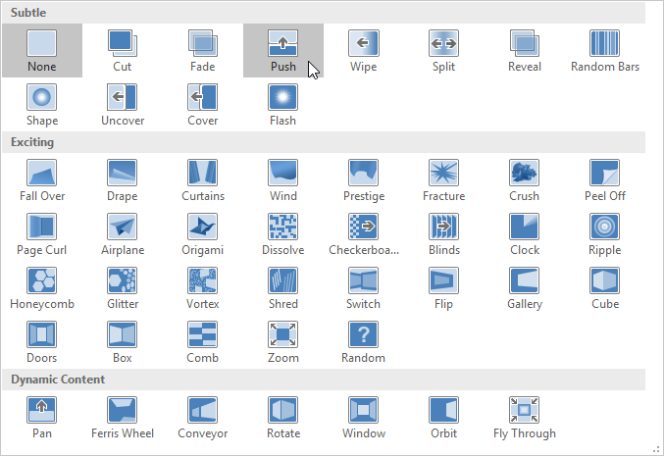

You can use the **Apply To All** command in the **Timing** group to apply the same transition to all slides in your presentation. Keep in mind that this will modify any other transitions you've applied.

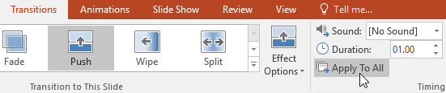

Try applying a few different types of transitions to various slides in your presentation. You may find that some transitions work better than others, depending on the content of your slides.

#### To preview a transition:

You can **preview** the transition for a selected slide at any time using either of these two methods:

* Click the **Preview** command on the **Transitions** tab.

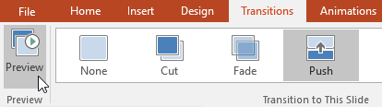

* Click the **Play Animations** command in the **Slide Navigation** pane.

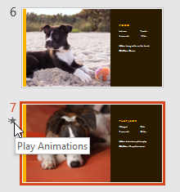

### Modifying transitions

#### To modify the transition effect:

You can quickly customize the look of a transition by changing its **direction**.

1. Select the **slide** with the transition you want to modify.
2. Click the **Effect Options** command and choose the desired option. These options will vary depending on the selected transition.

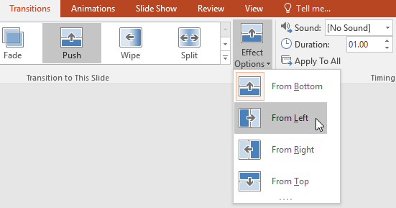

1. The transition will be **modified**, and a **preview** of the transition will appear.

Some transitions do not allow you to modify the direction.

#### To modify the transition duration:

1. Select the **slide** with the transition you want to modify.
2. In the **Duration** field in the **Timing** group, enter the **desired time** for the transition. In this example, we'll decrease the time to half a second—or 00.50—to make the transition **faster**.

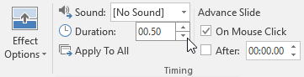

#### To add sound:

1. Select the **slide** with the transition you want to modify.
2. Click the**Sound** drop-down menu in the **Timing** group.
3. Click a **sound** to apply it to the selected slide, then preview the transition to hear the sound.

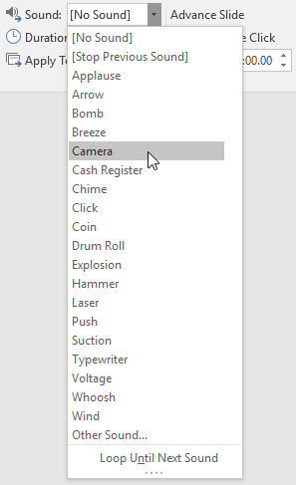

Sounds are best used in moderation. Applying a sound between every slide could become overwhelming or even annoying to an audience when presenting your slide show.

#### To remove a transition:

1. Select the **slide** with the transition you want to remove.
2. Choose **None** from the **Transition to This Slide** group. The transition will be removed.

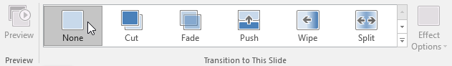

To remove transitions from **all slides**, apply the **None**transition to a slide, then click the **Apply to All** command.

#### Timing

|  |
| --- |
|  |

**Sound** – by use of this option we can enable sound to our slide when we moved one slide to next slide then it gives some sound on that moving.  
**Duration** -  
**Apply to All** - Set the transition between all the slides in the presentation to be the same as this slide.  
**On Mouse Click** - Lets you wait until there is a mouse click before moving on to the next slide.  
**After** -Lets you move to the next slide after a specific number of seconds.

### Animations Tab

#### Preview

|  |
| --- |
|  |

**Preview** - Preview the slide animations for the active slide.

#### Animation

|  |
| --- |
|  |

**Animation Styles** - gallery  
**Effect Options** –

**Animations**

To animate text or objects on a slide:

1. Select the text or object you want to animate.
2. On the **Animations** tab, select **Add Animation**, and select the animation you want from the drop-down.

To animate one line of text at a time, select one line of text, select an animation, select the next line of text, select an animation, ...

1. For **Start**, select **When Clicked**, **With Previous**, or **After Previous**.

You can also select the **Duration** or **Delay**.

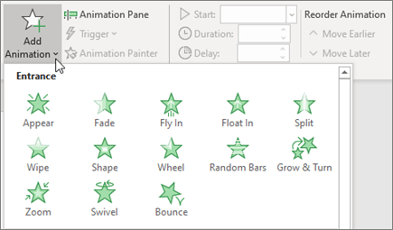

#### Advanced Animation

|  |
| --- |
|  |

**Add Animation** -  
**Animation Pane** -  
**Trigger** -  
**Animation Painter** –

1. Select the shape or object you want to add an animation to.
2. Go to **Animations** > **Advanced Animation** > **Add Animation** and select the animation you want to add.
3. Next, go to **Animations** > **Advanced Animation** > **Animation Pane**.

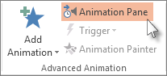

1. In the **Animation Pane**, select the animated shape or other object that you want to trigger to play when you click it.
2. In the **Advanced Animation** group, click **Trigger**, point to **On Click**, and then select the object.

### Trigger an animation to begin during a video or audio clip

To trigger an animation effect to play during a video or audio clip, you must first insert a bookmark at the desired point in the clip.

1. [Add a bookmark to your video or audio clip](https://support.microsoft.com/en-us/office/add-bookmarks-to-points-of-interest-in-audio-and-video-clips-eafb434f-5038-4c6a-93d0-428a9b68b7fa) for where you want to trigger an animation effect to begin.
2. Go to **Animations** > **Advanced Animation** > **Animation Pane**.
3. In the **Animation Pane**, select the animation effect that you want to begin at a certain point during the audio or video clip.
4. In the **Advanced Animation** group, click **Trigger**, point to **On Bookmark**, and select the bookmark that you want to trigger the animation to begin.

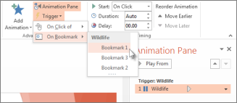

#### Timing

|  |
| --- |
|  |

**Start** -  
**Duration** - (Transition Speed in 2007)  
**Delay** -  
**Move Earlier** -  
**Move Later** -

### Slide Show Tab

#### Start Slide Show

|  |
| --- |
|  |

**From Beginning** - Start the slide show from the first slide.  
**From Current Slide** - Start the slide show from the active slide.  
**Broadcast Slide Show** - (Removed in 2010).  
**Custom Slide Show** - Drop-Down. The drop-down contains the commands: Custom Shows. Custom Shows displays the "Custom Shows" dialog box.

#### Setup

|  |
| --- |
|  |

**Set Up Slide Show** - Displays the "Set Up Show" dialog box.  
**Hide Slide** - Hides the current slide from the slide show. Hidden slides are indicated in the top left corner.  
**Record Narration** - (Removed in 2010).  
**Rehearse Timings** - Launches a full screen slide show allowing you to rehearse the transitions.  
**Use Rehearsed Timing** - (Removed in 2010)  
**Record Style Show** -  
**Play Narrations** -  
**Use Timings** -  
**Show Media Controls** -

#### Monitors

|  |
| --- |
|  |

**Resolutions** - Displays a list of available resolutions.  
**Show On** - (Show Presentation On in 2007).  
**Use Presenter View** - Toggles the display of speaker view on a second monitor.

### Review Tab

#### Proofing

|  |
| --- |
|  |

**Spelling** - (F7) it is use for spelling checker.  
**Research** - Toggles the display of the Research task pane.  
**Thesaurus** - (Shift + F7). Toggles the display of the Research task pane defaulting the research service to the thesaurus.

#### Window

|  |
| --- |
|  |

**New Window** - Opens a new window containing a view of the current presentation.  
**Arrange All** - Tile all open windows side by side on the screen.  
**Cascade** - Cascade all the open windows so they overlap.  
**Move Split** - Move the splitters to separate the different parts of the window.  
**Switch Windows** - Drop-Down.

**New Window** To open a new PowerPoint window, click this button. A new window will open with the same presentation. The presentation will have a number after the name.

**Arrange All** Click this button to tile the open windows on the screen side-by-side.

**Cascade Use** this button to tile the open windows so that they overlap vertically on the screen.

Move Split This option is used to move the splitters that separate the different sections of the window.

**Switch Windows** Click this button to switch from one window to another window. A list of the open windows will display when the button is clicked.

**Macros**

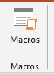

**Macros** These are miniature programs that are used to perform specified tasks within a program. Examples of Macros are Ctrl + P for print or Ctrl + S for save. When this button is clicked, a list of macros will be displayed.

**End of Report….**

**Thank you.**